We used Lucidchart and Lucidspark to create all the charts we needed for the project, and it worked well for the most part. We did run into an issue with Lucid’s “shape limit” while making our work breakdown chart. When we got halfway through creating it, the website stopped us from adding any more components. If this was a professional project, we would have paid for a premium plan (included in our theoretical budget), but instead we removed unnecessary arrows to reduce our shape count. Lucid’s free plan also limits users to 3 charts, which caused a minor issue which we resolved by having another member create the last chart we needed.

The team made good progress throughout the project timeline and we all managed to get our tasks done relatively on time. There were a few occasions where we completed a task but it later needed to be reworked to match a new structure or we ran into an error that needed to be fixed. These changes were done quickly and efficiently so we didn’t fall behind on our schedule.

Links to all project charts can be found here: <https://docs.google.com/document/d/1m0o3ZUQh2K1mfvxZPIUGk7Gd0UA-d3T3F1US-Qz48nA>

**Week 1:** 20/08 – 21/08

**Work Breakdown Chart**

(see included png file for proper visibility)

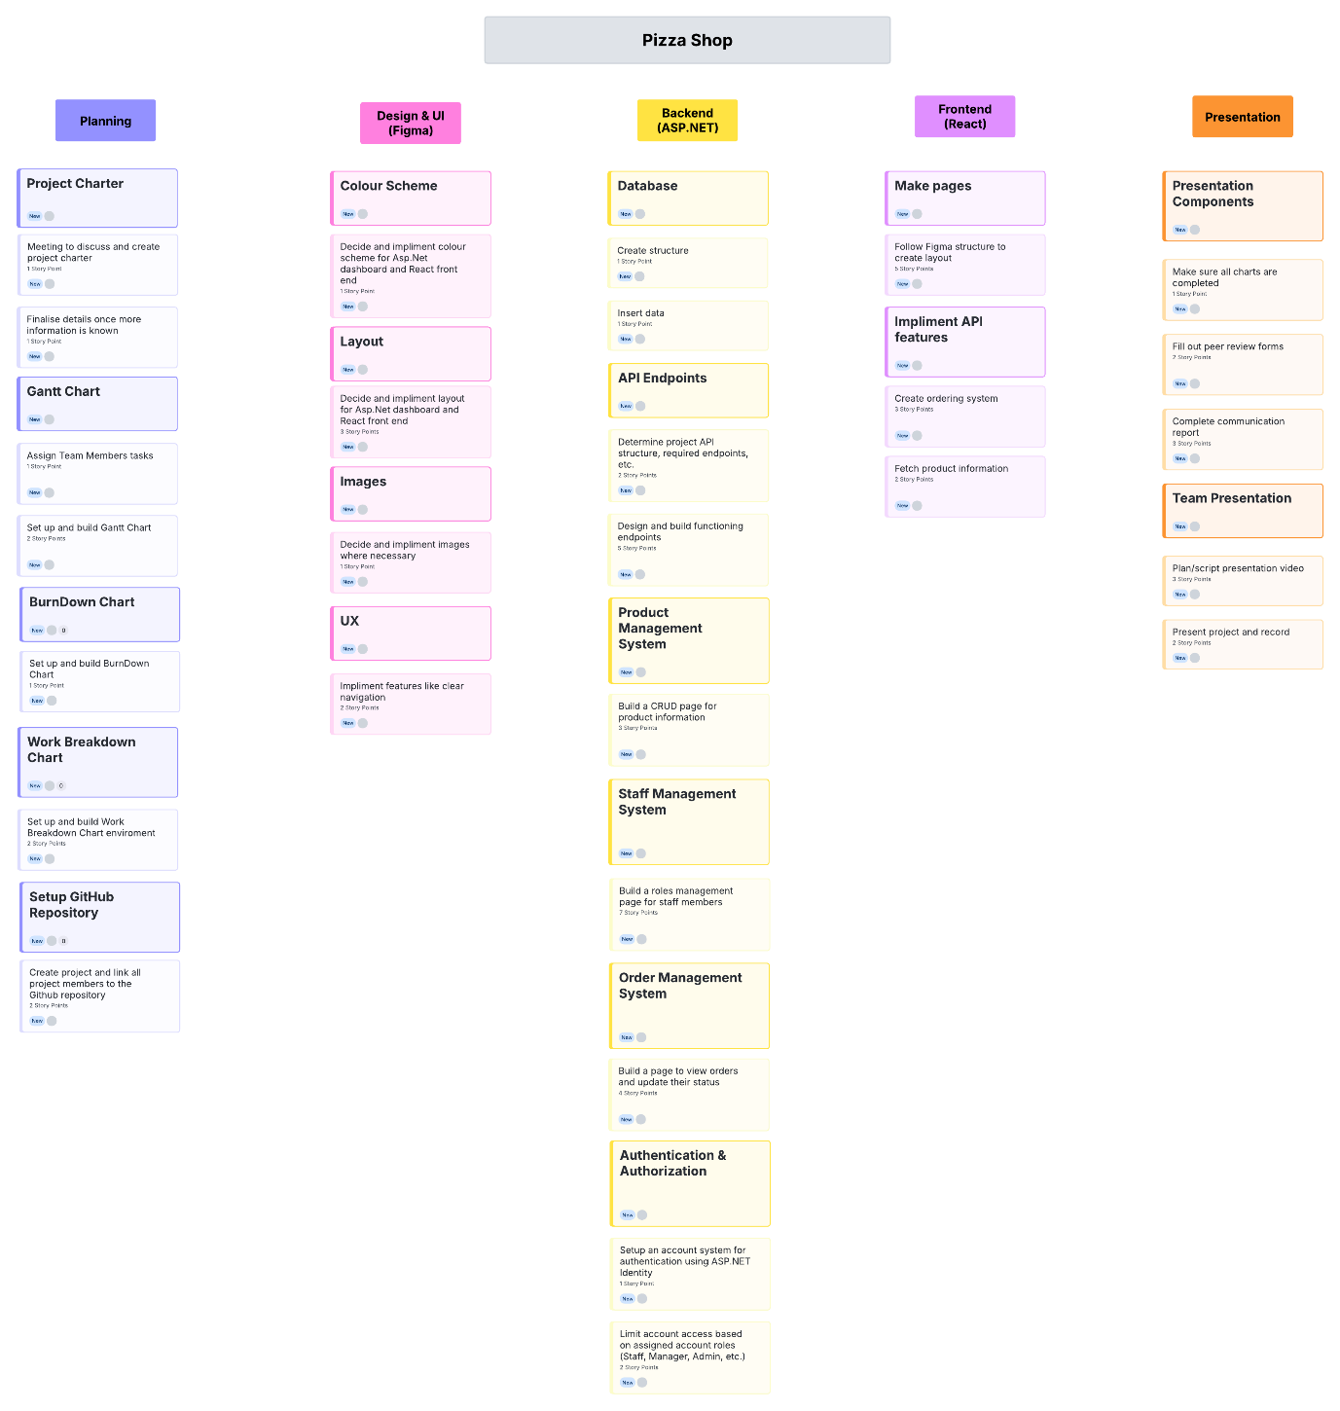

**Gantt Chart**

(Note: On Thursday, 2/3 team members were sick so no work was scheduled)

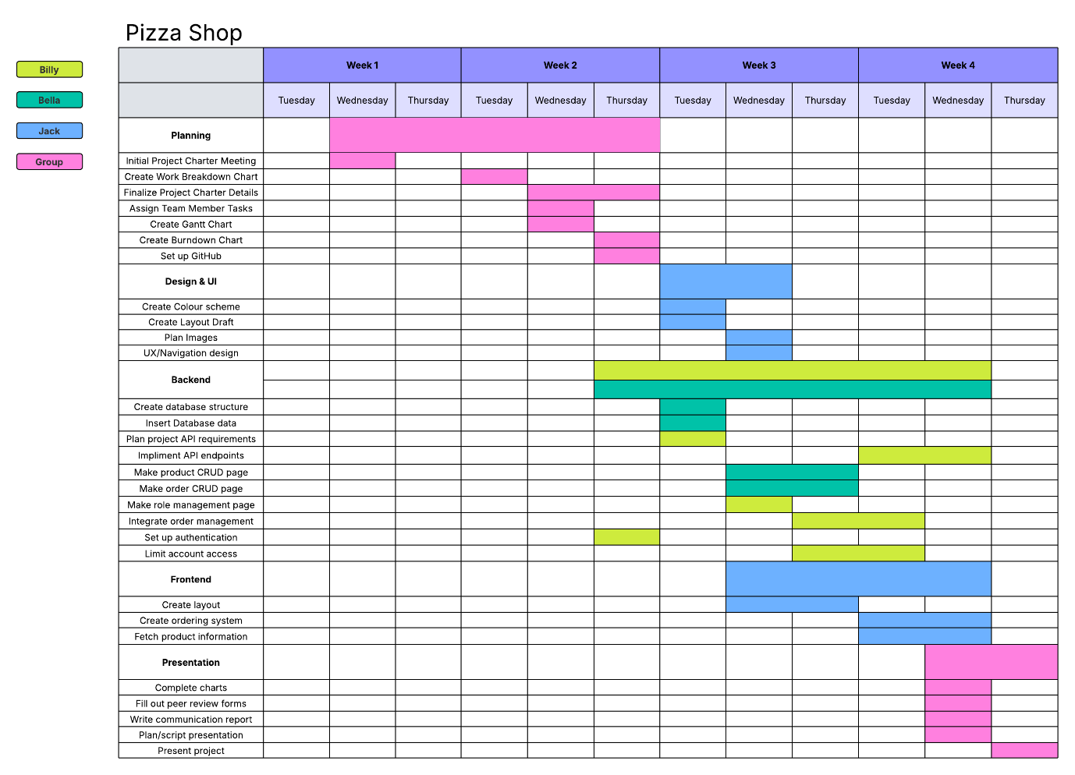

**Burndown Chart**

(Work began on Wednesday, which is why Week 1 consists of 2 days instead of 3)

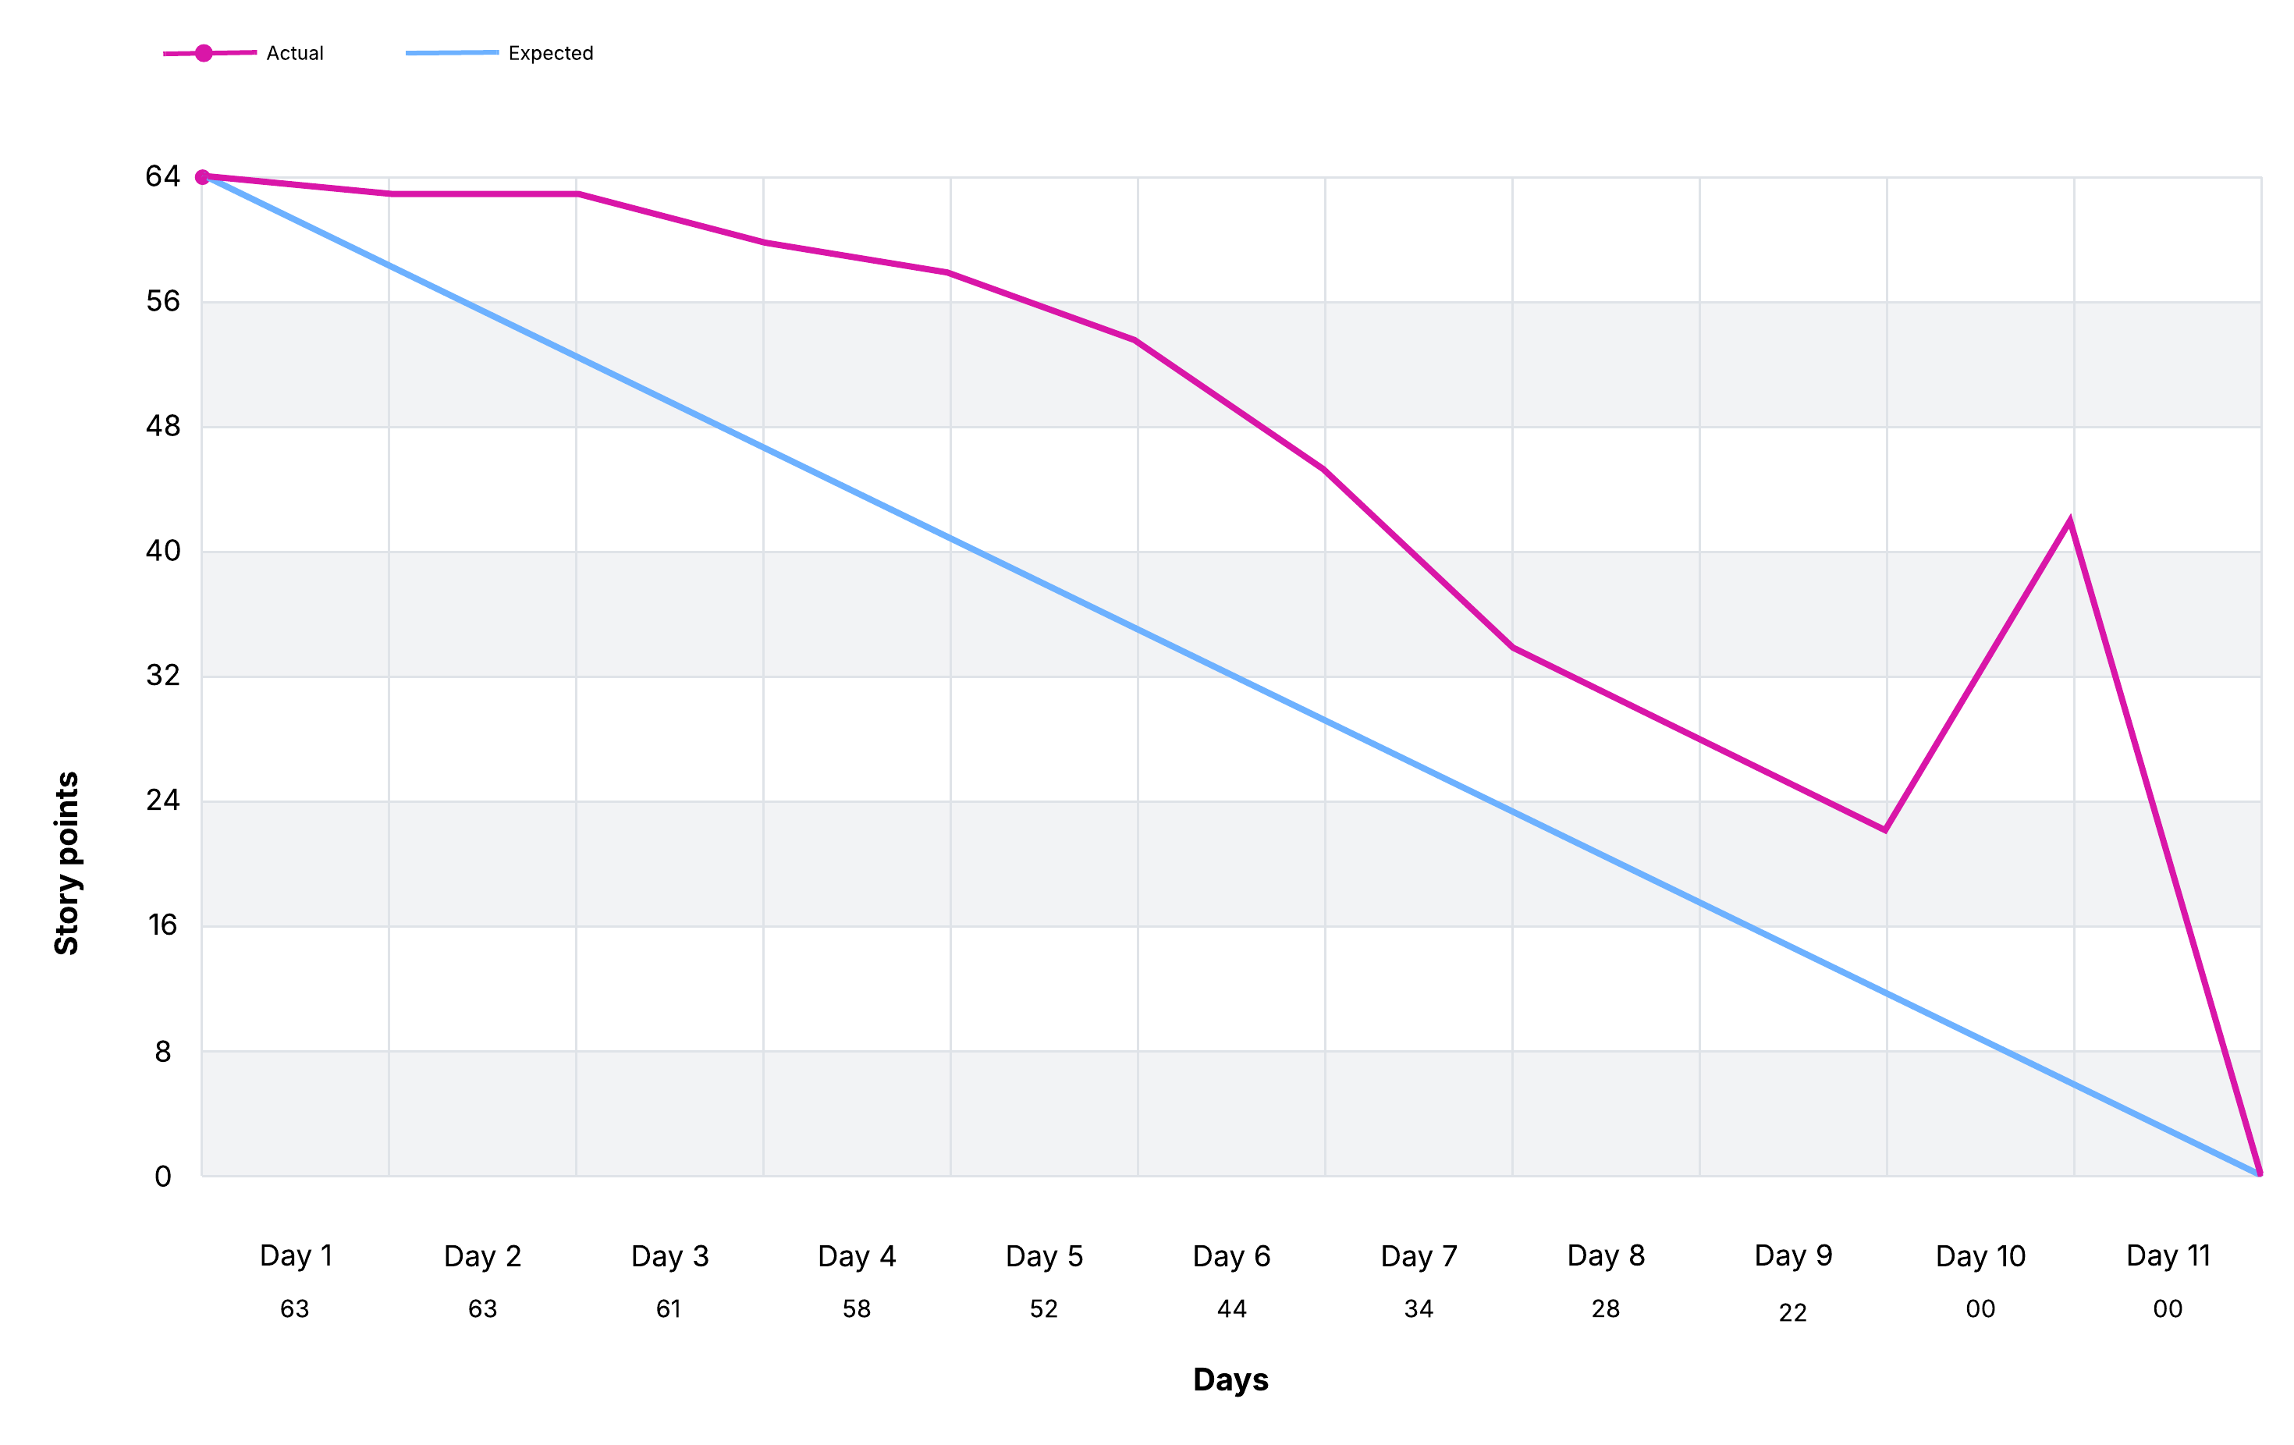

**Week 2:** 26/08 – 28/08

**Gantt Chart**



**Burndown Chart**



**Week 3:** 02/09 – 04/09

**Gantt Chart**



**Burndown Chart**



**Week 4:** 09/09 – 11/09

**Gantt Chart**

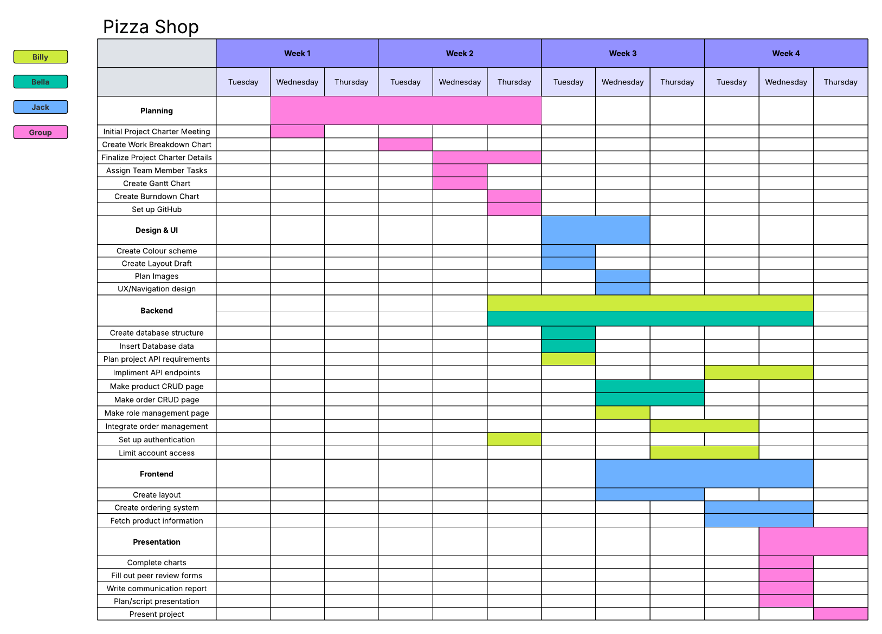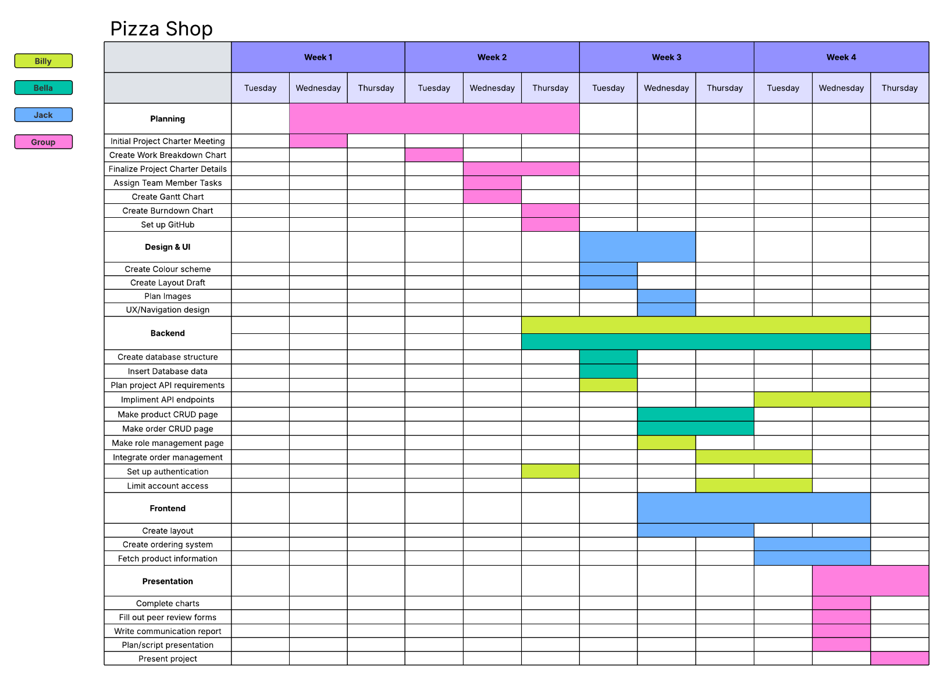

**Burndown Chart**

